Weakly Supervised Photo Enhancer Proposal

CSI 5139[Q]

September 28, 2018

Professor: Dr. Lang

Student Name & Number: Felix Singerman - 7970742

**Background:**

The paper I have chosen to present, and implement, was presented at the Computer Vision and Pattern Recognition (CVPR) conference in 2018 by A. Ignatov et al. from ETH Zurich, titled “WESPE: Weakly Supervised Photo Enhancer for Digital Cameras”. The paper presents a novel image-to-image Generative Adversarial Network (GAN) based architecture trained under weak supervision in order to mitigate the limitations of poor photo quality from mobile cameras and old photos.

Image enhancement can be performed by graphical artists or by using a specialized software that enhances the photo’s sharpness, contrast adjustments, and much more. However, this requires a set of skills that the day-to-day user might not have. Additionally, the process can be lengthy, and it is not possible to compute in a reasonable amount of time in the case of large-scale data processing. Past approaches to this problem have been through a supervised learning method which requires matched before/after learning pairs.

The paper proposes a deep learning architecture (see Appendix A) that “can be trained to enhance images by mapping them from the domain of a given source camera into the domain of a high-quality photos while not requiring any correspondence or relation between the images from these domains” (Ignatov et al., 2018). The only data required to train the network are two separate photo collections representing both domains.

**Proposed Work:**

I plan on basing my implementation based off of the previous work done by Ignatov et al. on their paper DPED for which the code can be found on GitHub. I will use the parts of their code that is shared between both papers and make the required adjustments to work for WESPE. I plan on implementing most of the contents of the paper. I will not implement the Flickr Faves Score and the User study. I will not be conducting comparison tests with a similar supervised learning method nor the commercial software baseline (the Apple Photos enhancement software). I will not be using all the datasets that are used in the paper and limit mine to only one of them(i.e.: cityscapes).

The contents of the paper will be implemented in Python using TensorFlow and other data science and machine learning libraries such as pandas, matplotlib, NumPy etc. I will follow the architecture proposed in the paper and implement each part of the algorithm: content consistency loss, adversarial color loss, adversarial texture loss, total variation (TV) loss, and the sum of losses, which is a linear combination of the other four losses (see Appendix B). I will use the KITTI (A. Geiger, 2012), Cityscapes (M. Cordts, 2016), and DIV2K (Agustsson, 2017) datasets for training.

Appendix A

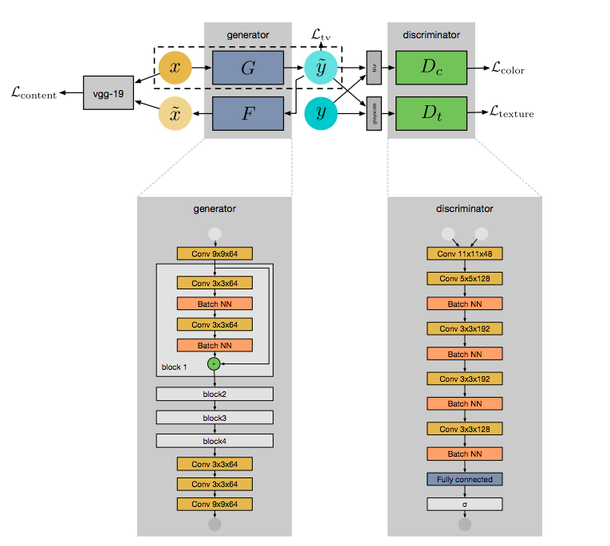

Figure 1: WESPE Architecture

Appendix B



Figure 2: Content Consistency Loss



Figure 3: Adversarial discriminator to differenciat between the blurred versions of enhanced and high quality images



Figure 4: Adversarial color loss



Figure 5: Adversarial texture loss



Figure 6: TV loss



Figure 7: Sum of losses

References

M. Cordts, M. Omran, S. Ramos, T. Rehfeld, M. Enzweiler, R. Benenson, U. Franke, S. Roth, and B. Schiele, “The Cityscapes Dataset for Semantic Urban Scene Understanding,” in *Proc. of the IEEE Conference on Computer Vision and Pattern Recognition (CVPR)*, 2016

A. Geiger, P. Lenz, and R. Urtasun. Are we ready for autonomous driving? the kitti vision benchmark suite. In Conference on Computer Vision and Pattern Recognition (CVPR), 2012.

A. Ignatov, N. Kobyshev, R. Timofte, K. Vanhoey, and L. Van Gool. WESPE: Weakly Supervised Photo Enhancer for Digital Cameras. *arXiv:1709.01118 [Cs]*. Retrieved from <http://arxiv.org/abs/1709.01118>, 2017

A. Ignatov, N. Kobyshev, R. Timofte, K. Vanhoey, and L. Van Gool. DSLR-quality photos on mobile devices with deep convolutional networks. In Proceedings of the IEEE International Conference on Computer Vision, 2017

Agustsson, Eirikur & Timofte, Radu. NTIRE 2017 Challenge on Single Image Super-Resolution: Dataset and Study. 1122-1131. 10.1109/CVPRW.2017.150, 2017